Name________________________
Variables and Patterns
Investigation 4.3
Problems A, B
Date ________________ Hour ____

- Use the distributive property to write an equivalent expression for 5x + 6x : ______________

- How does this help write an equivalent expression for n + n + n + 1 ?

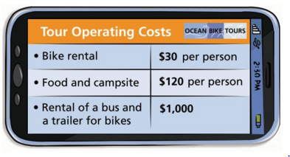

What equations show how the three cost variables depend on the number of riders n?

1. bike rental B = _______________

2. food and campsite fees F = _______________

3. rental of the bus and trailer R = ________________

Three of the business partners write
equations that relate total tour cost C
to the number of riders n:

1. Are any or all of these equations correct? If so, are they equivalent?
Explain why.

2. Compare the equations. Use order of operations to complete the table below.

Number of  Customers, n | 5 | 10 | 15 | 20 | 25
C = 30n + 120n +1000
C = 150n + 1000
C = 1150n

For each expression, use the properties of operations to write an equivalent expression.

1. 5x + x + 6 __________________________

2. 10y – 2y __________________________

3. Show that 1 + 3n = 4 + 3(n – 1)

