Moving Straight Ahead
Pre-Test

Name________________________
Date ________________ Hour ____

Admission to a museum is regularly $12 per person. Suppose that the same museum charges a school group $50 up front and only $5 for each ticket.

1) Write an equation for both the individual and group rate.

Individual rate: ________________________________________

Group rate: ________________________________________

2) Make a table showing both the individual and group prices for various numbers of admissions.

3) Sketch a graph showing both rates. Include axis labels.

4) Describe the relationship between number of people and the total cost of admission for both the individual and group rates.

5) Do either of these relationships represent a proportional relationship?
If so, which one and what is the constant of proportionality?

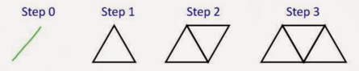
6)

A group of students is designing a bridge out of toothpicks. They use the above steps to create their bridge.
Write an equation to describe the number of steps, n, and the number of toothpicks needed, p.

b) Taylor came up with the following rules. Which, if any, describe the pattern?

p = 2(n+1) p = 2n + 1 p = n + 2 p = 1 + 2 + 2 + 2

7) Solve each equation for x. Show your work or explain your thinking.

a) –3x + 8 = 35 b) 12 – 4x = –2x + 3 c) –3(x – 1) = 12

8) Which of the following expressions is not equivalent to the others? Explain.

a) 4( y – 2) + 5 b) 4y – 3 c) 4(2 – y) + 5 d) 5 + 4y – 8

9) Use a rectangle diagram to show how to simplify the following expression:

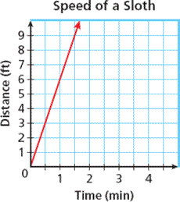
– 5( 1 – x)

10) Identify the constant of proportionality on the graph.
Explain how you know.

