Name________________________

***Filling and Wrapping***

**Test Review**

Date ________________ Hour ____

First, check all those topics you are confident about:

_____ Finding the surface area of a prism

_____ Finding the volume of a prism

_____ Giving dimensions of many prisms with the same volume

_____ Finding the circumference of a circle

_____ Finding the area of a circle

_____ Finding the surface area of a cylinder

_____ Finding the volume of a cylinder

_____ Comparing surface areas of different prisms

_____ Comparing volumes of different prisms or cylinders

_____ Explaining what pi represents

_____ Using nets to describe figures or solve problems

_____ Scaling the surface area of a figure

_____ Scaling the volume of a figure

_____ Explaining what surface area is, and how to find it

_____ Explaining what volume is, and how to find it

Second, make a plan for any topics you are not confident about. How will you study for the test tomorrow?

Now, here are some practice questions.

32 cm

8 cm

16 cm

16 cm

1. To the right is a net for a rectangular prism.

a. What are the dimensions of the box that can be made from the net?

b. What is the surface area of the box?

c. What is the volume of the box?

2. A candy company is marketing a special assortment of caramels. The company wants to put 40 individual caramels into a rectangular box. Each caramel is a 1-inch cube. The caramels should completely fill the box.

a. Which arrangement of caramels requires the **most** cardboard for the box?

How do you know?

b. Which arrangement of caramels requires the **least** cardboard for the box?

How do you know?

c. Make sketches of the boxes you described in parts (a) and (b). Label the dimensions.

d. Suppose each dimension of the box in part (b) were doubled.

How many caramels would fit in the new box? Show how you decided.

How many times more cardboard would be needed to make the new box?

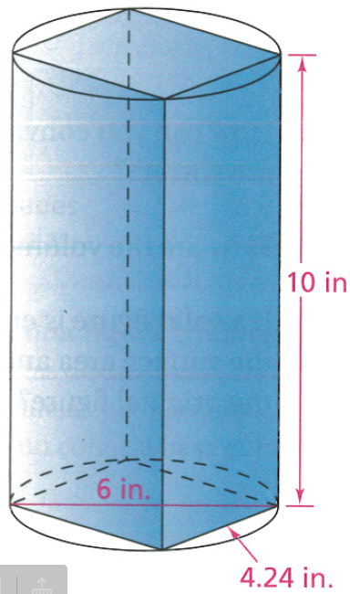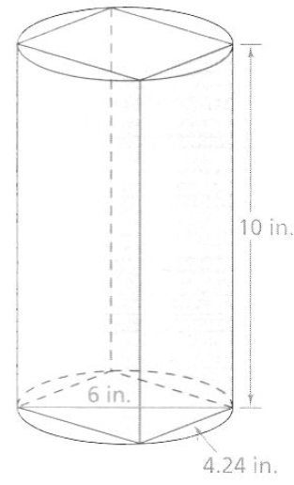

3. A beverage company has decided to change the packaging for a juice drink. The drink used to come in a cylindrical container with a base diameter of 6 inches and a height of 10 inches. The new container is a square prism that fits inside the old cylinder, as shown in the figure.

a. What is the volume of the original cylindrical container?

b. How much less juice can the prism-shaped container hold than the cylindrical container?

c. Suppose the company wants the cost per cubic inch of juice to be the same for both containers. The original container of juice cost $2.19. How much should the new prism-shaped container of juice cost?

4. What relationship does pi represent?

5. What is the circumference and area of one of the pancakes shown here:

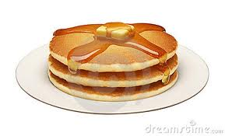

6 in

6. Silver dollar pancakes have a diameter half as long as the pancakes shown. How would the area of a silver dollar pancake compare to the area of the original pancake?

7. The circumference of a silver dollar pancake is 9.4 inches. How is this measure related to the diameter of the silver dollar pancakes?

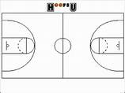

94 feet

50 feet

8) The area of the NBA free-throw circle is 113.1 ft2.

Find the radius, diameter, and circumference of the free-throw circle.

9. Here are 2 prisms. The second prism has dimensions that are all 4 times those of the first prism. How do the surface areas and volumes compare?

**To solve problems about surface area and volume of solid figures, you have to know the meaning of those terms and some strategies for calculating measurements from dimensions of a figure.**

10. What do ***volume*** and ***surface area*** measurements tell you about a solid figure?

11. Which formulas can you use to find the surface area and the volume of each figure?

a. rectangular prism b. cylinder

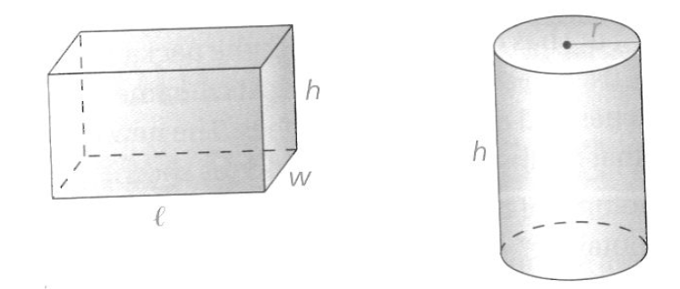

12. How can you convince someone that the formulas from #5 are correct?

13. If a solid figure is enlarged or reduced using a scale factor of *x,* how will the surface area and volume of the new figure be related to those of the original figure?