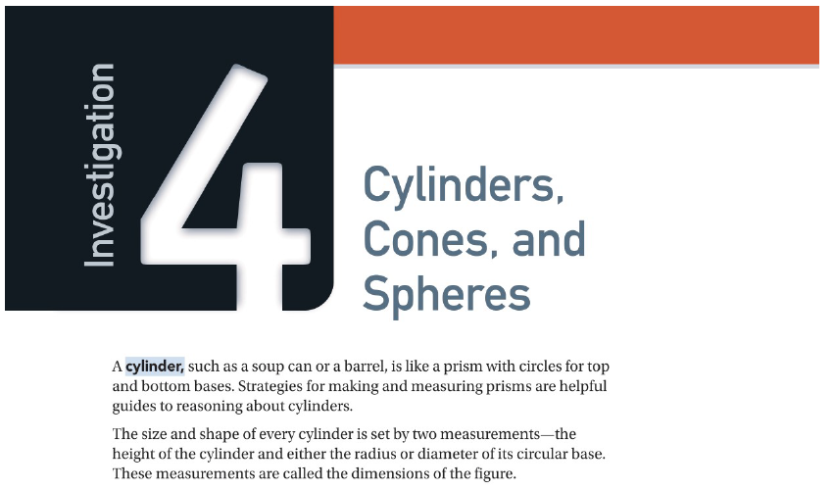
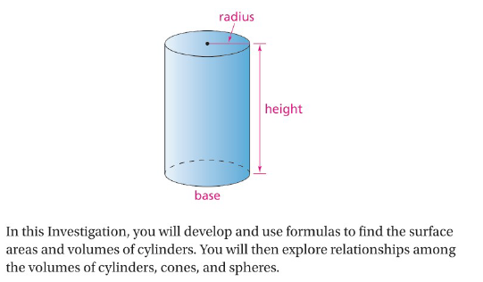
Name_____________________________

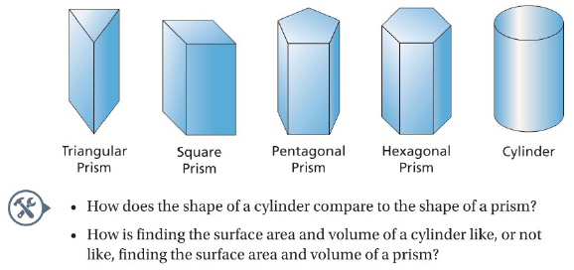

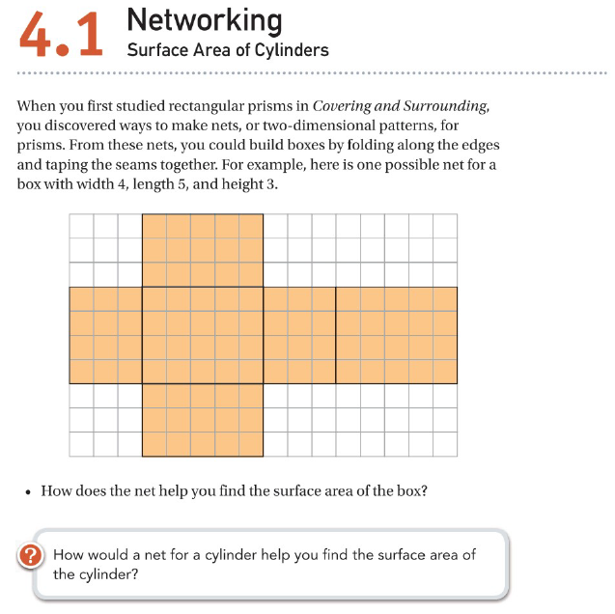

Name________________________
Filling and Wrapping
4.1 A – C
Date ________________ Hour ____

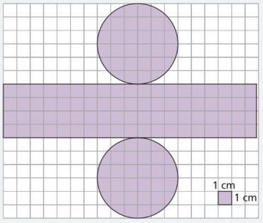

- What is the surface area of the cylinder?
Explain your reasoning.

- Cut out the net (on the last page.) Tape the pieces together to form a cylinder. What are the dimensions of the cylinder?

- Describe how the dimensions of the cylinder can help you find its surface area.

- How could you change the net without changing the cylinder the plan produces?

1. On the grid below, draw a net for a cylinder with a height of 5 centimeters and a base with radius 2 centimeters.

2. Calculate and record the dimensions of the circles and rectangle in the net.

Radius = ____________ Height = ____________

3. Calculate the surface area of the cylinder. Surface Area = ____________

The nets you studied and designed in Questions A and B show how you can calculate the surface area of any cylinder from its dimensions.

1. Describe a strategy for calculating the surface area of any cylinder.

2. Use your strategy to find the surface area of a cylinder with a height of 7 centimeters and a base with a radius of 4 centimeters.

4.2 ACE #4

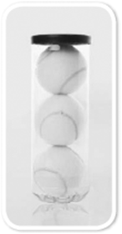

4. Tennis balls are usually packaged in cylindrical
containers of 3 balls like the one shown.

a. Which measure do you think is greater,
the height or the circumference of the container?

b. Why do you think this?

Name________________________
Filling and Wrapping
4.2
Date ________________ Hour ____

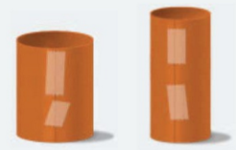
Imagine two identical sheets of paper held together by tape in the shape of cylinders.
The shorter dimension of the paper is the height of the first cylinder.

1. How do you think the volume of the first cylinder compares to the volumes of the triangular, pentagonal, and decagonal prisms we made in investigation 2.1?

2. Tape the longer ends of another sheet of paper together to form the second cylinder. The height of this cylinder is the longer dimension of the sheet of paper. Compare its volume to that of the first cylinder. Explain any differences you notice.

You can think about “filling” cylinders the same way that we did in problem 2.2,

Suppose a cylinder has a radius of 5 centimeters and height of 12 centimeters.

- How many one-centimeter cubes would it take to cover that circular base?
Explain.

- How many one-centimeter cubes would it take to fill the entire figure? Explain.

- If a cylinder has radius r and height h, explain in words how you can find the volume V of this cylinder.

Write a formula for V in terms of r and h. V = ______________
In question A, one cylinder had a circumference equal to the length of the longer side of the sheet of paper and a height equal to the length of the shorter side. The other cylinder had the opposite dimensions. How does the formula you just wrote in question B help to explain the difference in the volumes of the two cylinders?

A cylinder with a radius of 5 cm and height of 12 cm has a volume of 300π cm³.

1. Which change in the dimensions of the cylinder would cause the greater change in volume: doubling the height, or doubling the radius?

2. How many times larger is the volume if both the radius and the height are increased by a scale factor of 2?

By a scale factor of 3?

Explain:

3. How many times larger is the surface area if both the radius and the height are increased by a scale factor of 2?

By a scale factor of 3?

Explain:

Filling and Wrapping
4.2 ACE

5. A cylinder has a radius of 3 centimeters. Sand is poured into the
cylinder to form a layer 1 centimeter deep.
a. What is the volume of sand in the cylinder?

b. Suppose the height of the cylinder is 20 centimeters. How many
1-centimeter deep layers of sand are needed to fill the cylinder?

c. What is the new volume of the cylinder?

For Exercises 4 and 5, find the surface area and volume of each cylinder.

6. height = 10 cm, radius = 6.5 cm

7. height = 6.5 cm, radius = 10 cm

Cut this one out for 4.1, Question A #2.

