Name________________________
Filling and Wrapping
Investigation 3.1
ACE
Date ________________ Hour ____

Name the diameter & radius.
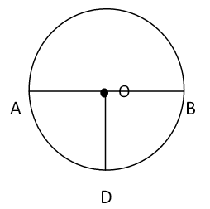
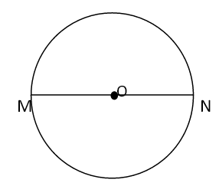
2) Diameter: ______ 3) Diameter: ______

Radius: ______ or Radius: ______ or ______

______ or ______

For Exercises 1–4, identify the lighter part of the circle as its circumference, diameter, or radius. Then, using a ruler, measure that part in centimeters
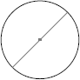
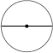
1. 2.

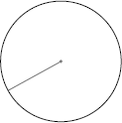
3. 4.

5. When you order a round pizza, you can often choose between 10”, 12”, and 16”.
These measurements are the pizza’s diameter. What would the radius be for each pizza?

Pizza diameter | 10” | 12” | 14”
Pizza radius

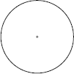
6. Draw three different diameters on the circle.
a. What is the measure, in centimeters, of each diameter?

b. What can you say about the measures of diameters in a circle?

c. Estimate the circumference of this circle using
the diameter measurements you found.

7. Draw three different radii on the circle. (RAY dee eye, the plural for radius).

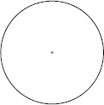
a. What is the measure, in centimeters, of each radius?

b. What can you say about the measures of the radii in the
same circle?

c. Estimate the circumference of this circle using the radius
measurements you found.

8. Terrell says that when you know the radius of a circle, you can find the diameter by doubling the radius. Do you agree? Why or why not?

9. Enrique says that when you know the diameter of a circle you can find the radius. How can he find the length of a radius if he knows the length of the diameter?

