Name________________________
Filling and Wrapping
Investigation 2.1
ACE
Date ________________ Hour ____

1. Suppose that the polygons below were drawn on centimeter grid paper. How many 1-centimeter cubes (some cut in pieces) would it take to cover each polygon?

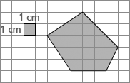
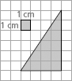
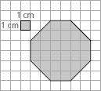
- b. c.

2. Using the method from Problem 2.1, Darius and Mariana made paper prisms from 4 inch-by-6 inch pieces of paper. One has an equilateral triangle for its base, another has a square base, and the third has a regular hexagon for its base. The height of each prism is 4 inches.
To find the areas of the base and top polygons, they traced and measured those figures, as accurately as they could, to get the data shown below. The figures are not drawn to scale.
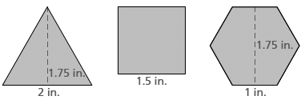

a. What are the areas of the sides of each prism?

b. What are the perimeters of the bases (and tops) of the each prism?

c. What are the areas of the bases (and tops) of each prism?

