Name________________________

***Filling and Wrapping***

**Investigation 1.3**

***ACE***

Date ________________ Hour ____

******Find the Surface Area and Volume for each rectangular prism**

**1. 2.**

SA = _____________ SA = _____________

V = ______________ V = ______________

**3.** Amazon shipped a box to my house that had a volume of 360 in3.

What are three possible sets of dimensions that would create a box with that volume?

|  |  |  |  |
| --- | --- | --- | --- |
|  | **Box #1** | **Box #2** | **Box #3** |
| **Length** |  |  |  |
| **Width** |  |  |  |
| **Height** |  |  |  |

Which of these boxes would have the least surface area? How do you know?

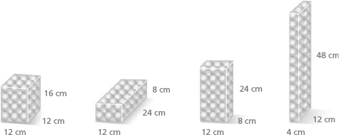**4.** Each of these boxes holds 36 table-tennis balls.

1. Without calculating, which box has the least surface area? Why?
2. Check your guess by finding the surface area of each box.

**5.** Liquids, such as juice or milk, and solids, such as rice or cake mix, are often

packaged in rectangular boxes. Because the material settles easily into a box

of any dimensions, there are many packaging possibilities.

What are the volume and surface area of a box that has width 3.5 centimeters,

length 10 centimeters, and height 15 centimeters?

**23.** The square prism below has a volume of 100 cubic centimeters. What is its height?

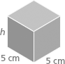

**24.** The rectangular prism below has a surface area of 158 square centimeters.

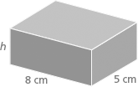What is its height?

**22.** A company that makes compost boxes of various sizes charges $500  
to set up its equipment for production. It then adds a charge per box  
of $0.15 per square foot based on the surface area of the box.

**a.** The Science Club plans to order compost boxes to sell at Back-to-School Night. The boxes have length 3 feet, width 2 feet, and height 1 foot. What is the surface area of each box?

**b.** How much will it cost the club to buy 100 boxes?

200 boxes?

1,000 boxes?

**c.** What equation relates cost of a box order *C* to number of boxes  
ordered *n*? Is this a proportional relationship? Explain.

**d.** If the club wants to spend at most $750 on its box order, how  
many boxes can it purchase?