Candy Cartons Day Two Names_____________________________

____________________________

Date_______________________hour____

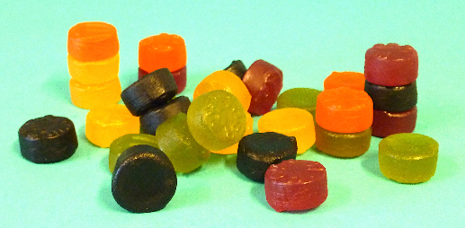
Remember, your design must take into account the following:
- The 18 candies are 1 cm deep and 2 cm across
- The carton must be made from a single sheet
- The design should require as little cutting as possible

1) What factors might be important in the design of the best candy carton?

2) With your table partner, share a favorite design from yesterday, describing its shape and positive characteristics.

3) Discuss the different choices, and then choose one design to work with.
(Remember, the goal is to create a candy carton that will use the least material and still be effective.)

4) Write a description of the shape of your chosen carton, including the dimensions:

________________________________________________________________________

________________________________________________________________________

________________________________________________________________________

________________________________________________________________________

________________________________________________________________________

________________________________________________________________________

________________________________________________________________________

5) Use the grid provided to draw the net of your chosen carton.

6) Find the surface area and volume of your carton.

Surface Area Volume

7) Cut out your design.

8) What are the best characteristics of your carton? _____________________________

________________________________________________________________________

________________________________________________________________________

________________________________________________________________________

________________________________________________________________________

________________________________________________________________________

________________________________________________________________________

9) How do you think your carton could be improved? _____________________________

________________________________________________________________________

________________________________________________________________________

________________________________________________________________________

________________________________________________________________________

________________________________________________________________________

________________________________________________________________________

